**实验1：猴子摘香蕉问题**

1. 实验目的

（1）熟悉谓词逻辑表示法；

1. 掌握人工智能谓词逻辑中的经典例子——猴子摘香蕉问题的编程实现。

二、问题描述

房子里有一只猴子（即机器人），位于a处。在c处上方的天花板上有一串香蕉，猴子想吃，但摘不到。房间的b处还有一个箱子，如果猴子站到箱子上，就可以摸着天花板。如图1所示，对于上述问题，可以通过谓词逻辑表示法来描述知识。要求通过C/C++/python语言编程实现猴子摘香蕉问题的求解过程。

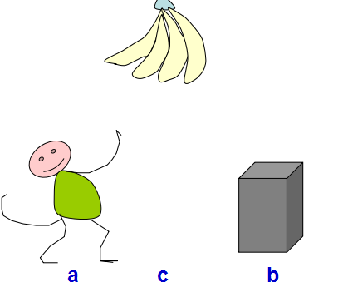

图1 猴子摘香蕉问题

三、编写程序并调试

四、撰写实验报告（实验目的、源程序、实验过程与结果、体会与总结）

实验目的：学习人工智能的基础理论，谓词逻辑表示法。

截图：

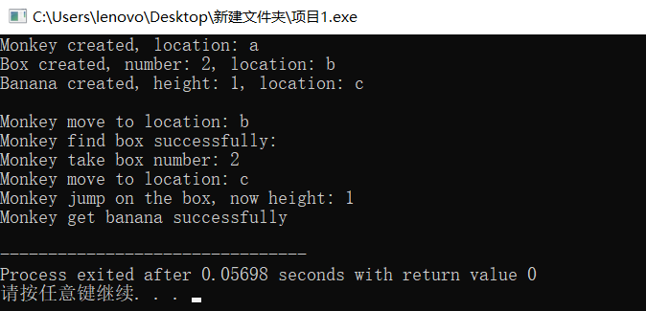

源程序：

#include <iostream>

using namespace std;

enum location

{

a,

b,

c

};

char get_location(location lo)

{

switch (lo)

{

case 0:

return 'a';

case 1:

return 'b';

case 2:

return 'c';

}

}

inline location set_location(char lo)

{

switch (lo)

{

case 'a':

return (location)0;

case 'b':

return (location)1;

case 'c':

return (location)2;

}

}

class Box

{

public:

location box_location;

int box_number;

Box(location lo, int number)

{

box_location = lo;

box_number = number;

cout << "Box created, number: " << box_number << ", location: " << get_location(lo) << endl;

}

Box() { }

};

class Banana

{

public:

int height;

location banana_location;

Banana(location lo, int height)

{

banana_location = lo;

this->height = height;

cout << "Banana created, height: " << height << ", location: " << get_location(lo) << endl;

}

};

class Monkey

{

public:

location monkey_location;

bool find;

Box box;

int height;

bool banana_find;

Monkey(location lo)

{

monkey_location = lo;

find = false;

height = 0;

banana_find = false;

cout << "Monkey created, location: " << get_location(lo) << endl;

}

void move(location lo)

{

monkey_location = lo;

cout << "Monkey move to location: " << get_location(lo) << endl;

}

void find_box(Box box)

{

if (box.box_location == monkey_location)

{

this->box = box;

find = true;

cout << "Monkey find box successfully: " << endl;

}

}

void take_box()

{

if (find = true)

{

cout << "Monkey take box number: " << box.box_number << endl;

}

}

void jump_on()

{

if (find = true)

{

height++;

cout << "Monkey jump on the box, now height: " << height << endl;

}

}

void get_banana(Banana banana)

{

if (banana.banana_location == this->monkey_location &&

banana.height == this->height)

{

banana_find = true;

cout << "Monkey get banana successfully" << endl;

}

}

};

int main(int argc, char** argv)

{

location lo = set_location('a');

Monkey monkey(lo);

lo = set_location('b');

Box box(lo,2);

lo = set_location('c');

Banana banana(lo,1);

cout << endl;

monkey.move(set_location('b'));

monkey.find_box(box);

monkey.take_box();

monkey.move(set_location('c'));

monkey.jump_on();

monkey.get_banana(banana);

return 0;

}

实验结果：成功完成了预期任务，猴子成功拿到了香蕉。

实验体会与总结：通过该实验，我感受到了人工智能理论与之前学过的基础理论的区别，我们在学习这门课的时候应当拥有一种全新的思维。